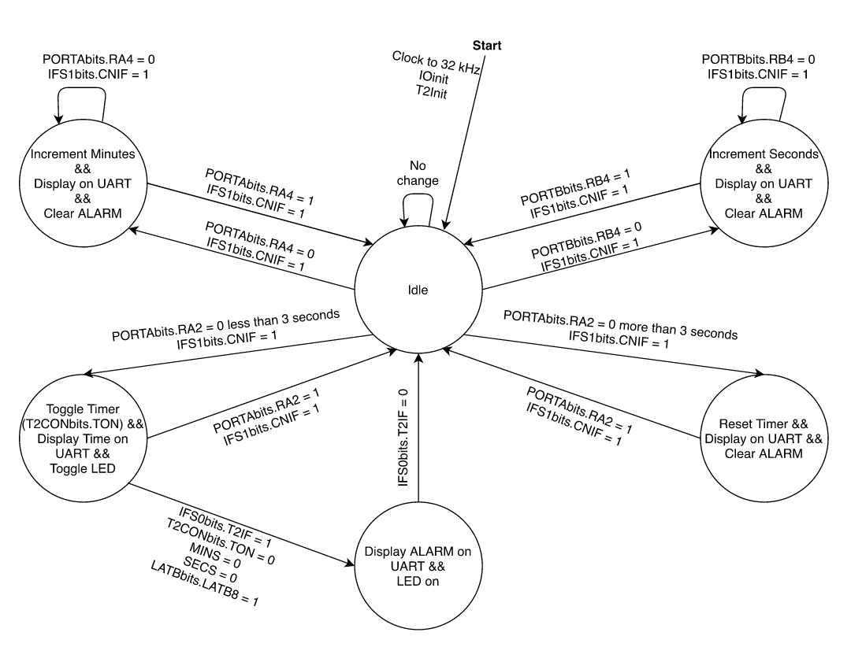ENCM511 -App1 – Group 10 B01

Michael Tagg – 30080581

Vincent Zheng – 3007628

Christina Truong